BISWAJIT ROUT
B.Tech(Hons.) Plastic Engineering
Contact No: 9937986793
E-mail: routbiswa93@gmail.com
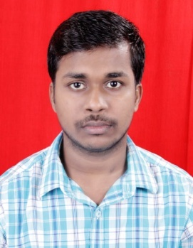
Present Address: Opposite of P.H.D COLONY , Po- Charbatia , PS- Choudwar ,
Dist- Cuttack , State- Odisha

CAREER OBJECTIVE :
To work in a firm with a professional work driven environment where i can utilize and apply my knowledge , skill which would enable me as a fresh graduate to grow while fulfilling organisational goals.

BASIC ACADEMIC CREDENTIALS
Qualification | School/College name | Board/University | Year | Percentage
B.Tech(Plastic  Engineering) | Central Institute Of Plastics Engineering And Technology | BPUT(Biju patnaik University of Technology | 2017 | 71.2%  (CGPA-7.62)
Intermediate(+ 2) | Stewart Science College | CHSE( Council of Higher Secondary Education) | 2013 | 67%
School (10th) | Saraswati shishu vidya mandir | BSE (Board of secondary education) | 2011 | 87%

EXPERIENTIAL LEARNING (SUMMER INTERNSHIP PROGRAM)
Company name: HARI PLAAST Pvt. Ltd.
Project title : Study and operation of manufacturing process of pipes and fittings by Extrusion moulding process.
Duration : 1Month

SUMMER COURSE :
Specialization training : AUTO CAD
Institute : CIPET
Duration : 1Month

ACADEMIC PROJECT:
Project topic: “Development of wood fiber composites and analysis of their applications to replace the natural domestic furniture.”

CO-/EXTRA-CURRICULAR ACTIVITIES:
- Member of event organizing committee of CIPET , Bhubaneswar
- Actively participated in various sports
- I am also a kickboxer , got a Gold medal in kickboxing.

ACCOMPLISHMENTS :
- Won a gold medal in kickboxing in state level in the year 2007
- Won a first prize in intra-college symposium in the year 2015
Topic: “ NON-STICK SURFACE COATING OF AN AEROPLANE”

INTERPERSONAL SKILL :
- Ability to generate new ideas and creativity.
- Ability to cope up with different situations.
- Confident and Determined.
- Ability to build relationship and set up trust.
- Highly motivated and eager to learn new things.
- Strong motivational and leadership skill

PERSONAL DETAILS :

- Father’s Name - PRASANT ROUT
- Permanent Address- - P.H.D colony opposite , po -charbatia , ps- choudwar,
Dist- cuttack, Pin- 754028
- Date of birth- - 26th July 1996
- Language known- - English , Hindi , Odia
- Marital status- - Single
- Nationality/Religion- - Indian/
- Interest & Hobbies- - Reading space related books and novels , playing cricket ,
Football, travelling, listening music , volunteer work.

DECLARATION:
I do hereby declare that the information is true to the best of my knowledge.

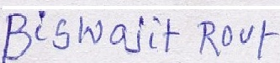
Place:....................... _______________
Date: ( Signature)

